THE UNIVERSITY OF CALGARY
FACULTY OF ENGINEERING

Final Examination
(Fall, 1998-99)

ENGG 201 - Behaviour of Liquids, Gases and Solids

December 18, 1998 Time Allowed: 3 hours

1. Attempt all eight (8) questions. Weighting as noted. Total marks =100.
2. The text-book and electronic calculators are permitted. Notes are not allowed.
3. Please write your final answers in the boxes provided.

_______________________________________________________________________________

Surname:_____________________ Given Name(s):________________ ID No.:_______________

Section:  (tick one) |  | L01  RAH |  | L02  J Azaiez
_______________________________________________________________________________

ENGG 201, Final Exam., Fall-1998-99 1

Question Number I (10 Marks)
The temperature-composition diagram shown is for vapour-liquid-liquid equilibrium in mixtures of methyl alcohol (methanol) and n-heptane at a pressure of 400 mmHg. Methanol is used as a gasoline additive.
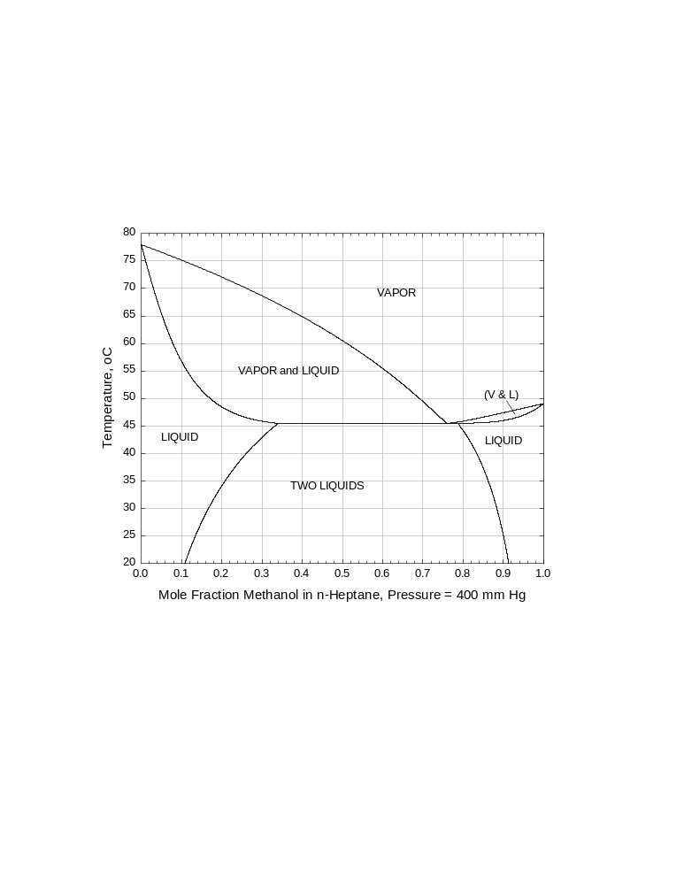
(a) From the diagram, what is the boiling temperature of methanol at 400 mmHg?
What is the boiling temperature of n-heptane at 400 mmHg?

(b) A mixture contains 5.00 kmol of methanol and 5.00 kmol of n-heptane and is held at a constant pressure of 400 mmHg.
(i) At what temperature is the mixture all vapor in equilibrium with the first drop of liquid?
(ii) What is the mole fraction of methanol in the equilibrium liquid?

(c) The mixture in part (b) is held at 400 mmHg and 25 ºC.
(i) How many phases are present?
(ii) State the mole fraction of methanol in each phase and say whether the phase is a liquid or a vapor.
(iii) Calculate the number of kilomoles of each phase.

ENGG 201, Final Exam., Fall-1998-99 2

Question Number II (15 Marks)

Acetone has a vapour pressure of 53.3 kPa at 39.5 ºC and 202.6 kPa at 78.6 ºC.

(a) From the above data, obtain an equation to correlate the vapour pressure of acetone. (The equation should be in the form 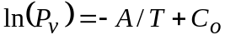 where P_{v} is in kPa units. Find numerical values for A and C_{o}.)
ln(P_{v})=-A/T+C_{o}
A=ln(P_{v2}/ P_{v1})/(1/T₁-1/T₂)=3756K
C_{o} =ln(P_{v1}) +A/ T₁ = 15.989
Therefore, ln(P_{v})=-3756/T+15.989, where is P_{v} in kPa.

(b) Estimate the average heat of vaporization of acetone in the temperature range 39.5 to 78.6 ºC.

A= ΔHv/R ➔ ΔHv =R*A=8.314 (kJ/kmol.K)*3756(K)= 31.22 MJ/kmol

(c) Estimate the acetone's critical pressure from your equation. The critical temperature is 508.1 K.
ln(P_{vC})=-3756/T_{C}+15.989
with T_{C} =508.1 K, we get P_{vC} =5414 kPa.

(d) At 78.6 ºC, the solvent 2-butanone has a vapour pressure of 98.2 kPa. (See the problem statement for the vapour pressure of acetone at this temperature.) Calculate the pressure at which a liquid mixture that is 30 % acetone and 70 % 2-butanone is in equilibrium with a vapour at 78.6 ºC. What is the mole fraction of acetone in the vapour?

T=78.6ºC➔ Acetone, P_{v1}=202.6kPa
2-butane, P_{v2}=98.2kPa
P=x₁P_{v1} +x₂P_{v2} =0.3*202.6 +0.7*98.2=129.5kPa
y1=( x₁P_{v1})/P=0.3*202.6/129.5=0.469.

ENGG 201, Final Exam., Fall-1998-99
3
Question Number III (15 Marks)

Ethane is held at a very low pressure (0.100 Pa) and a temperature of 0 ºC. The collision diameter of ethane is 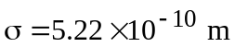 and its molar mass is 30.07 kg/kmol.

(a) Calculate the number of gas molecules per cubic metre.
n/v = P/RT
ρ_{N}= P/kT= N_{A}*(P/RT)=6.023 10²⁶*(10⁻⁴/8.314*273.15)=2.65 10¹⁹/m³

(b) On average, how far will an ethane molecule travel before colliding with another molecule when the pressure is 0.100 Pa and the temperature is 0 ºC?
We need to determine the mean free path:
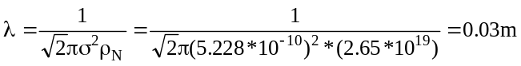

(c) Calculate the mean speed of ethane molecules when the pressure is 0.100 Pa and the temperature is 0 ºC.

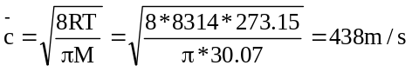

(d) At 0 ºC and 0.100 Pa, the thermal conductivity of an (unidentified) ideal gas is 0.100 W/m K.
(i) Estimate the thermal conductivity of this gas at 600 K and 0.100 Pa.
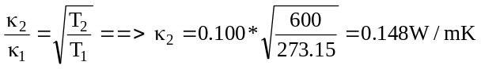
(ii) Estimate the thermal conductivity of this gas at 0 ºC and 100 kPa.

κ does not change with P if T is constant.
ENGG 201, Final Exam., Fall-1998-99 4

Question Number IV (15 Marks)

Freon-13 (chlorotrifluoromethane) has critical properties 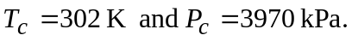

(a) Calculate the a and b parameters in the van der Waals equation for freon-13.

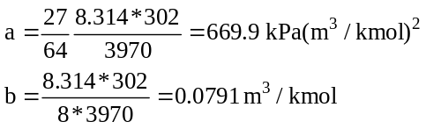

(b) Estimate the pressure if 2.00 kmol of freon-13 at 100 ºC occupy 1.00 m³. Use the van der Waals equation.
N=2kmol, v=1m³, Vm=0.500 m³/kmol
P= RT/(Vm-b) –a/(Vm)² =4690kPa

(c) Use the method of corresponding states and Kay's rule to calculate the volume when a mixture containing 2.00 kmol of freon-13 and 1.00 kmol of freon-12 (dichlorodifluoromethane) are held at 100 ºC and 6.00 MPa. The critical properties of freon-12 are 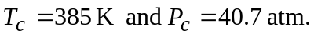

P_{pc} =(2/3)*3970 +(1/3)*4124=4021kPa
T_{pc} =(2/3)*302 +(1/3)*385=329.7K
Pr=P/ P_{pc} = 1.497
Tr= T/ T_{pc} = 1.13
From page397, Z =0.55
Vm= ZRT/P =0.284 m³/kmol

V = n*Vm= 3*0.284=0.853 m³

ENGG 201, Final Exam., Fall-1998-99 5

Question Number V (10 Marks)

The interior of a typical house is 20 ºC in a winter when the air in the attic space is -30 ºC. The house is insulated from the attic by 1.50 cm of wall-board with a thermal conductivity of 0.500 W/m K and a layer of wood chips 10.0 cm deep with a thermal conductivity of 0.06 W/m K. The ceiling area is 130 m².

(a) What is the rate of heat loss from the house into the attic space, in units of Watts?
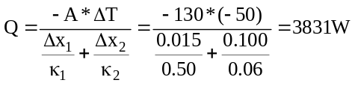

(b) A layer of fibre-glass insulation, 16.0 cm thick, with a thermal conductivity of 0.042 W/m K, is added to the attic.

What is the rate of heat loss from the attic with the additional insulation, in Watts?

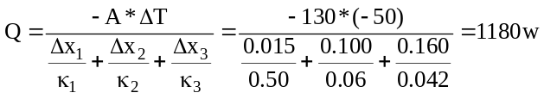
ENGG 201, Final Exam., Fall-1998-99 6

Question Number VI (10 Marks)

(a) An oil has a viscosity of 0.01 Pa s at 100 ºC. At 0 ºC its viscosity is 2.00 Pa s.
(i) Correlate the viscosity of the oil with the equation 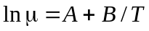. Give numerical values of A and B, showing all units.

B=ln(μ₂/ μ₁)/(1/T₂-1/T₁)=5400K
A= ln(2) -5400/273.15=-19.076
➔ ln(μ) = 5400/T -19.076

(ii) Estimate the viscosity of this oil at -40 ºC.
ln(μ) = 5400/T -19.076
At T=-40ºC=233.15K, ln(μ) =4.084 or μ=59.4Pa.s

(b) The properties of a slurry are tested with a Fann viscometer. The results of two measurements are: shear stress = 50.8 Pa when shear rate = 510.6 s⁻¹; shear stress = 25.4 Pa when shear rate = 170.2 s⁻¹.
(i) Determine the power-law parameters for this slurry.
τ= K(du/dy)n
ln(τ) = ln(K) +n*ln(du/dy)
n = ln(τ₂/ τ₁)/[ln((du/dy)₂/(du/dy)₁)]=0.631
K = τ₁/[(du/dy)₁]=0.993 Pa.s^{0.631}

(ii) Calculate the apparent viscosity of the slurry when the shear stress is 50.8 Pa.
μapp=τ/(du/dy)=0.995Pa.s

ENGG 201, Final Exam., Fall-1998-99 7

Question Number VII (15 Marks)

(a) A liquid with a density of 930 kg/m³ moves through a horizontal steel pipeline that is 50 m long with an inside diameter of 5.00 cm. The liquid viscosity is 3.00 mPa s and the observed average velocity in the pipe is 2.00 m/s.
What is the pressure drop in the pipe?

Re = ρuD/μ= 3.1*10⁴ ➔ f=0.007
-(ΔP)/L = 2fρu²/D ➔ -ΔP =52kPa

(b) A liquid with a density of 930 kg/ m³ moves through a horizontal pipeline that is 50 m long with an inside diameter of 5.00 cm. The liquid viscosity is 0.300 Pa s and the observed pressure drop in the pipe is 50.0 kPa.
What is the average velocity of the liquid in the pipe?

Since the viscosity is high, we will assume that the flow is laminar
-(ΔP)/L = 32μu/D²
u= -ΔP *D²/(32 μ L)=0.26m/s

Check Reynolds number, Re= ρuD/μ = 40<2000.
ENGG 201, Final Exam., Fall-1998-99 8

Question Number VIII (10 Marks)

A given brass has a Young's modulus of 101 GPa and a Poisson's ratio of 0.35. The coefficient of linear expansion of this brass is 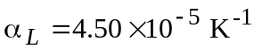.
(a) What is the bulk modulus of this brass?
K= E/3(1-2ν) =1.12*10¹¹ Pa

(b) A rod made of the above brass has a square cross-section 0.500 cm by 0.500 cm and is 2.00 m long. A mass is suspended from the rod (where the acceleration due to gravity is 9.81 m/s²) thereby applying a tension stress. The length of the rod increases by 2 mm.
What is the suspended mass, in kilogram units?
εy= 0.002/2 = 10⁻³
σy = E* εy = (101*10⁹)*(10⁻³)=1.01*10⁸ Pa.

Fy= σy *A=2525N
M= Fy/g=252kg

(c) The rod is initially 2.00 m long at 10 ºC. The temperature was raised and the length of the rod increased by 2 mm.
What was the final temperature (i.e., when 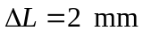)?
ΔL/L = α_{L}ΔT ➔ 0.002/2 = 4.5*10⁻⁵*(T₂-10)
➔ T₂=32.2 ºC

